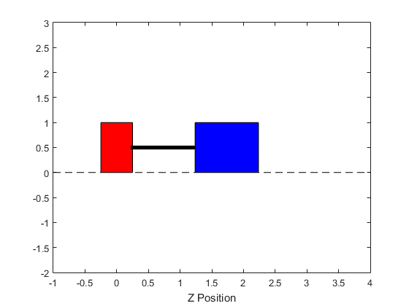**D.2**: Mass Spring Damper Animation

**E.2**: Ramp and Ball Animation

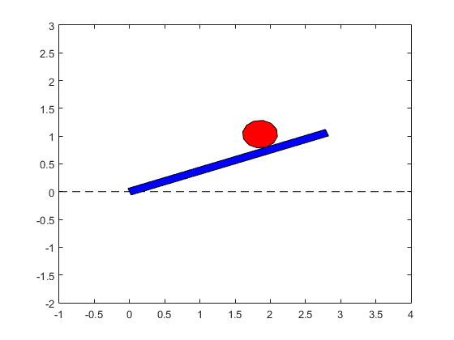

**G.2**: Planar VTOL Animation

